Internet App And Web Developement Assignment Documentation
By Ciarán O'Loughlin -> C13358011

The assignment was to create a functioning website that interacted with an sql database. I have managed to accomplish this task and also intergrated a login screen for extra complexity
My first page, the login screen basically just operates as a form to enter the username and password into to be processed
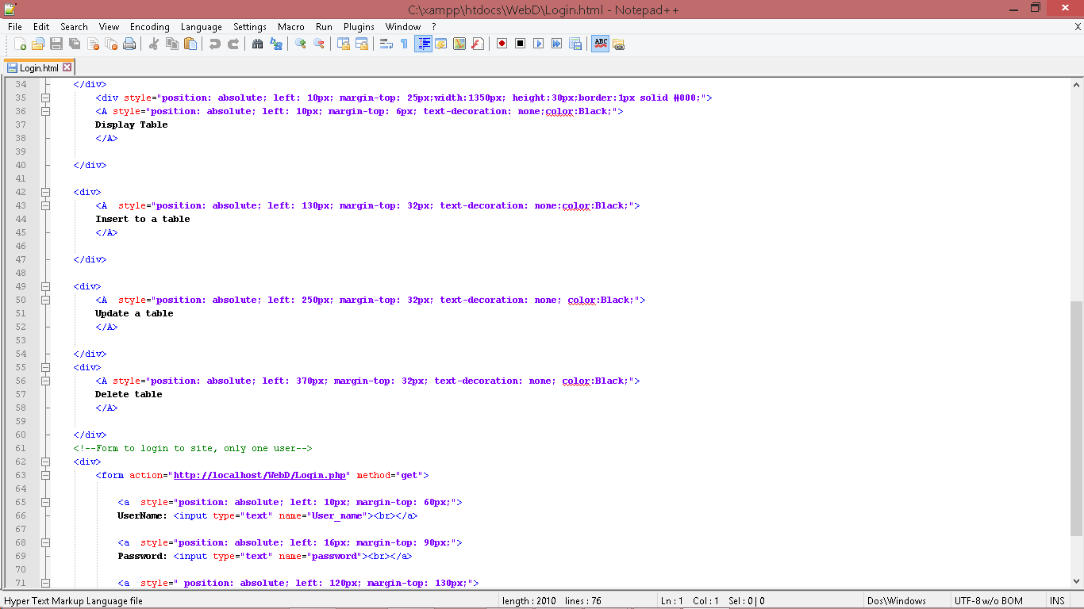
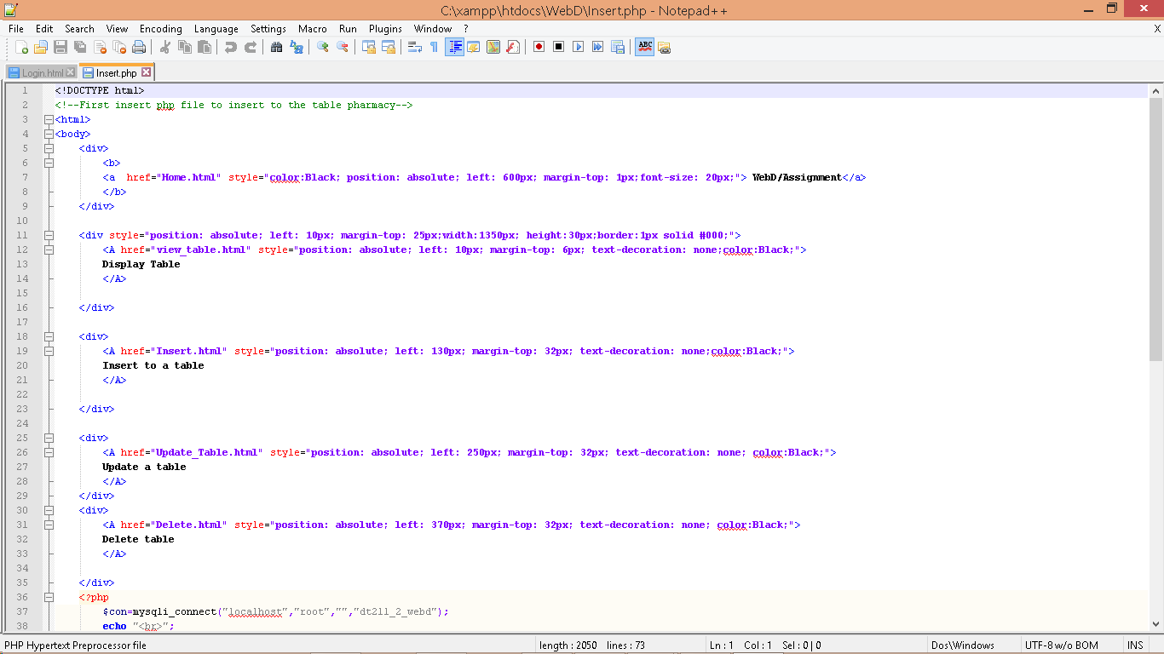

After there is just a home page with the a banner appering over it displaying the various options the user can preform

This is a screenshot of the webpage at the homepage screen as you can see there is a bar and tittle, all the words in the bar are links to do seperate things in the database, like for example clicking on view tables will bring you to a page where you can select what table you wish to view. From there the webpage then brings you to a php page that processes you request and acesses the requested table and displays all the rows in that table, See picture below.
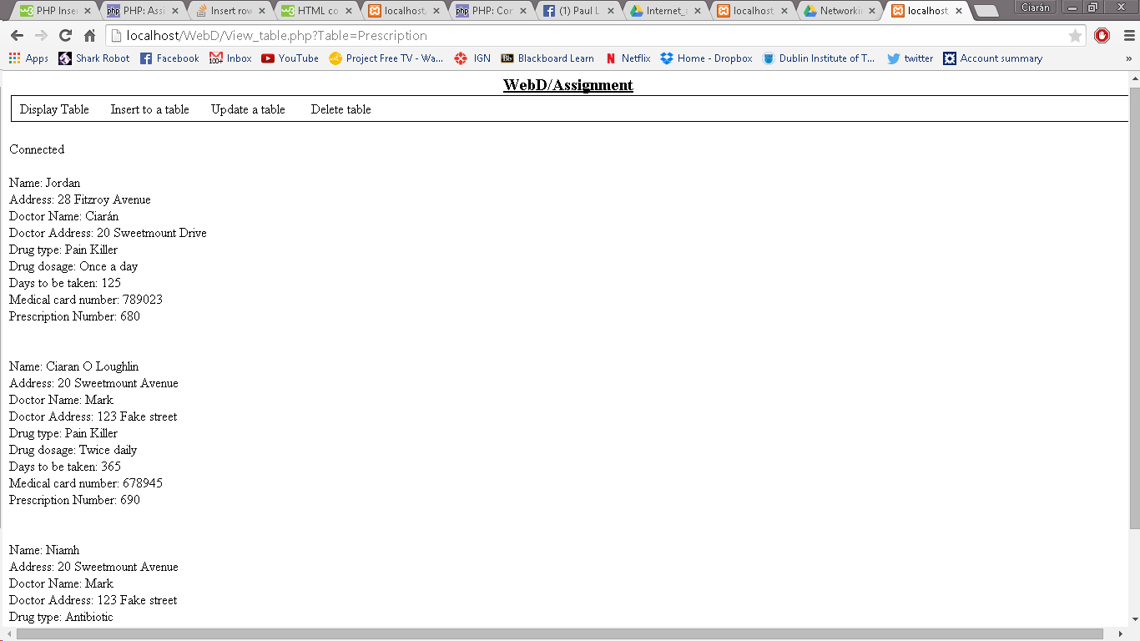
Overall there was nothing hugely problamatic with the assignment apart from a few problems with integrating php with html and a few smaller problems than that. I think my project as a whole came out rather well and I am quite happy with the end result.

